Font Helvetica Neue

Front of T-shirt


Weight Insight Mentor

www.ths-wim.com

Back of T-Shirt

"Know Thyself"

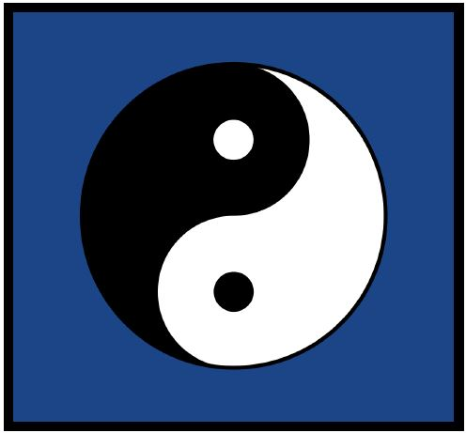

Measure. Learn. Adapt.

THS - The Heap Stack

WIN - Weight Insight Mentor

